MTX series

MJPEG compression processor

Rev 2

Data Sheet

Table of Contents

1 Overview 3
2 Key specifications 3
3 Targeted application 4
4 System level description 5
4.1 Architecture Overview 5
4.2 Pin Configuration and Functions 6
4.3 Image Sensor interface Timing 9
4.4 MJPEG data interface Timing 10
4.5 Frame Dimension 11
4.6 Ratings 12
5 Package Specifications 13
6 Ordering information 14
7 Revision history 15
8 Disclaimer 15

Overview

The MTX is an Image Compression Processor series that performs the JPEG Baseline Algorithm. The MTX performs Discrete Cosine Transform, Quantization, and Entropy Encoding. It does not use any external memory and is designed to operate without any host intervention.
The MTX series has different options. Its base option is MTX001. It includes a Lattice Semiconductor FPGA ICE40UP5K, packaged in a 30-ball WLCSP and in a 48-pin VFQFN Exposed Pad, preconfigured with the MJPEG encoder IP.

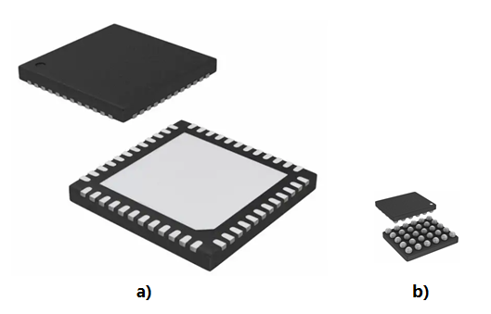

Figure 1. a) MTX001-48; b) MTX001-30

Key specifications

- Image Sensor interface
- Pixel input data 8 bits YUV 4:2:2
- Pixel clock 25MHz max
- ITU-R compliant parallel digital video interface timing

- Host interface paralleled to data interface
- 8 bits JPEG compressed data
- 1-bit data enabled pulse. Data enabled pulse duration equals to period of Pixel clock

- Selectable 4 compression rates
- Standard Huffman Tables
- No external memory
- No programming required
- Latency 8 times of Frame length
- Image resolution 4K, 2K, VGA
- Image Sensor OV7690 CameraCube default configuration
- Package
  - 7.0mm x 7.0mm 48-pin VQFN
  - 2.5mm x 2.1mm 30-Ball WLSC
- Customization availability

Targeted application

The MTX001 is designed for products that record video. Some examples are:

- Small action cameras
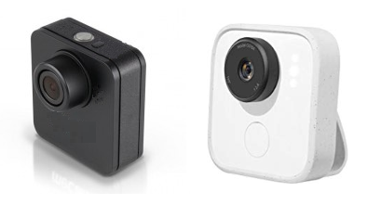
- Wireless doorbells
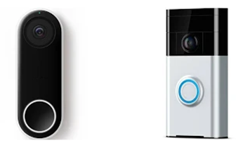
- Surveillance cameras
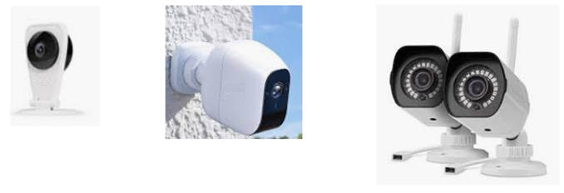
- Tracking device with camera capability
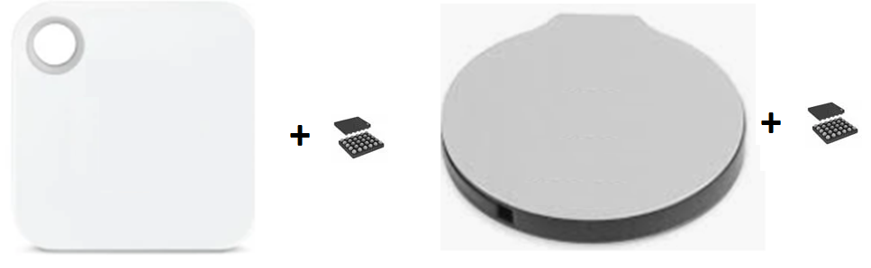
- Smart wallets with camera
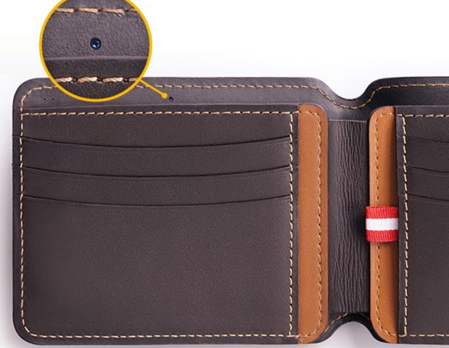
- Drone cameras
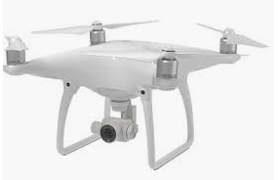

System level description

Architecture Overview

The MTX001 performs JPEG Baseline compression for both Still Image and Real Time Video streams. Figure 2 shows the simplified block diagram of this device.

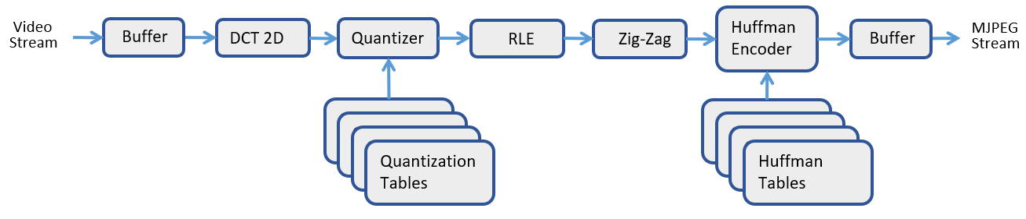

Figure 2. MJPEG encoder simplified block diagram

Pin Configuration and Functions

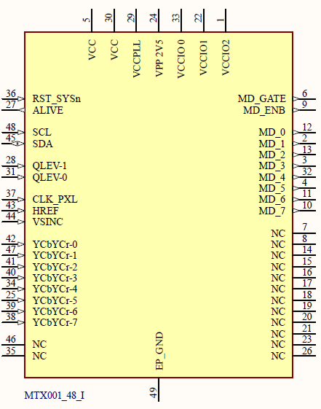
Figure 3. MTX001-48-x pinouts

Table 1 lists the pin descriptions and their corresponding pin numbers for the MTX001-48 base version.

Table 1. Pin descriptions
Pin# | Name | Description | Direction
36 | RST_SYSn | System Reset. Active Low.  Pulled-up 10k internally
27 | ALIVE | “Heart Beat” pulses | out
48 | SCL | SCCB clock to Image Sensor.  4.7k pull-up to 3.3V required | out
45 | SDA | SCCB data to/from Image Sensor.  4.7k pull-up to 3.3V required | inout
28 | QLEV-1 | Quant level selecting bit 1.  Pulled-up 10k internally | in
31 | QLEV-0 | Quant level selecting bit 0.  Pulled-up 10k internally | in
37 | CLK_PXL | Pixel Clock from Image Sensor | in
43 | HREF | Horizontal reference from Image Sensor | in
44 | VSYNC | Vertical sync from Image Sensor | in
42 | YCbYCr-0 | YCbYCr Pixel data bit 0 from Image Sensor | in
47 | YCbYCr-1 | YCbYCr Pixel data bit 1 from Image Sensor | in
41 | YCbYCr-2 | YCbYCr Pixel data bit 2 from Image Sensor | in
40 | YCbYCr-3 | YCbYCr Pixel data bit 3 from Image Sensor | in
34 | YCbYCr-4 | YCbYCr Pixel data bit 4 from Image Sensor | in
25 | YCbYCr-5 | YCbYCr Pixel data bit 5 from Image Sensor | in
39 | YCbYCr-6 | YCbYCr Pixel data bit 6 from Image Sensor | in
38 | YCbYCr-7 | YCbYCr Pixel data bit 7 from Image Sensor | in
6 | MD_GATE | MJPEG data Gate | out
9 | MD_ENB | MJPEG data enable signal | out
12 | MD-0 | MJPEG data bit 0 | out
2 | MD-1 | MJPEG data bit 1 | out
13 | MD-2 | MJPEG data bit 2 | out
3 | MD-3 | MJPEG data bit 3 | out
32 | MD-4 | MJPEG data bit 4 | out
4 | MD-5 | MJPEG data bit 5 | out
11 | MD-6 | MJPEG data bit 6 | out
10 | MD-7 | MJPEG data bit 7 | out
49 | EP_GND | Exposed Pad for grounding | -
5 | VCC | Power supply, Core, 1.2V | -
30 | VCC | Power supply, Core, 1.2V | -
33 | VCCIO0 | Power supply, I/0 bank 0, 3.3V | -
22 | VCCIO1 | Power supply, I/0 bank 1, 3.3V | -
1 | VCCIO2 | Power supply, I/0 bank 2, 3.3V | -
29 | VCC_PLL | Power supply, PLL, 1.2V | -
24 | VCC_PP | Power supply, Configuration Memory, 2.5V | -
7 | NC | Not Connected | -
8 | NC | Not Connected | -
14 | NC | Not Connected | -
15 | NC | Not Connected | -
16 | NC | Not Connected | -
17 | NC | Not Connected | -
18 | NC | Not Connected | -
19 | NC | Not Connected | -
20 | NC | Not Connected | -
21 | NC | Not Connected | -
23 | NC | Not Connected | -
26 | NC | Not Connected | -
35 | NC | Not Connected | -
46 | NC | Not Connected | -

The four levels of quant levels selecting by the input signals applying to pins
QLEV-1 and QLEV-0
"11" - Level 0
"10" - Level 1
"01" - Level 2
"00" - Level 3

During the initial powering up or after system reset, the Image Sensor OV7690 CameraCube is configuring through SCCB interface (SCL and SDA pins). OV7690 default configuration stored in MTX001-48-x. Afer configuration finished, the “Heart Beat” pulces generated from the pin ALIVE. MTX001-48-x is ready to receive the the frame from the image sensor, JPEG compressing image frames, and sending compressed data to out.

Other than OV7690, a different image sensors could be connected to MTX001-48-x. However in this case the image sensor should be configured from the external I2C interface.

Image Sensor interface Timing

Image sensor interface timing diagram shown in Figure 3.

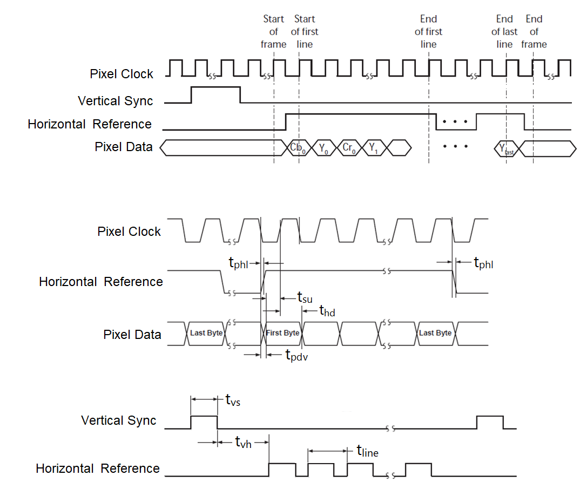
Figure 4. Image Sensor interface timing diagram

Table 2 lists the image sensor interface timing parameters and descriptions for the MTX001.

Table 2. Image Sensor interface timing parameters
Symbol | Description | Min | Max | Unit
f_{pclk} | Pixel Clock frequency | 10 | 25 | MHz
t_{pclk} | Pixel Clock period | 40 | 100 | nsec
t_{su} | Data Setup time | 7.7 |  | nsec
t_{hd} | Data Hold time | 1.1 |  | nsec
t_{phl} | Pixel Clock [↓] to Horizontal Reference [↓] | 0 | 5 | nsec
t_{pdv} | Pixel Clock [↓] to Data-out Valid | 0 | 5 | nsec
t_{line} | Video frame width | - | - | nsec
t_{vh} | Vertical Sync [↓] to Horizontal Reference [↑] | 8 × t_{line} | - | nsec
t_{vs} | Vertical Sync width | 2 × t_{pclk} | - | nsec

MJPEG data interface Timing

MJPEG data interface timing diagram is shown in Figure 4.

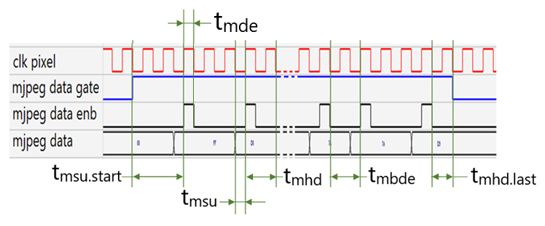
Figure 4. MJPEG data interface timing diagram

Table 3 lists the MJPEG data interface timing parameters and descriptions for the MTX001.

Table 3. MJPEG data interface timing parameters
Symbol | Description | Duration
t_{msu} | MJPEG Data Setup time | T_{pixel_clock} / 2
t_{msu.start} | Last MJPEG Data Setup time | 5 * T_{pixel_clock} / 2
t_{mhd} | MJPEG Data Hold time | 3 * T_{pixel_clock} / 2
t_{mhd.last} | Last MJPEG Data Hold time | T_{pixel_clock}
t_{mde} | MJPEG Data Enable width | T_{pixel_clock} / 2
t_{mbde} | Interval between consecutive MJPEG Data Enables, min | 3 * T_{pixel_clock} / 2

Frame Dimension

Frame image dimensions shown in Figure 5.

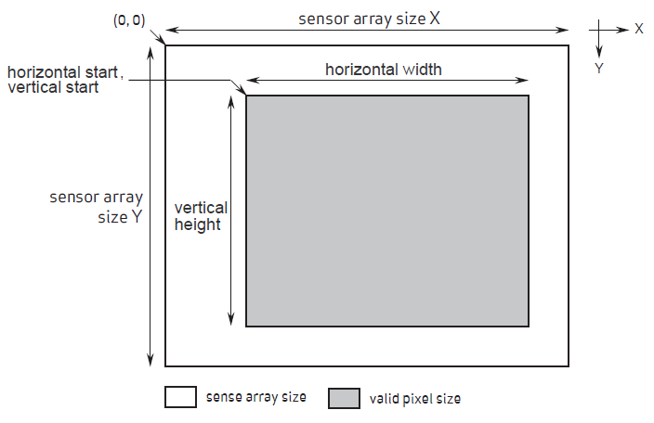

Figure 5. Frame image dimensions

The frame’s horizontal width and vertical height calculate automatically.

The horizontal width has the following constraints:
- Value should be divided by 32
- Max value is 4096

The vertical height has the following constraints:
- Value should be divided by 32
- Max value not limited

Ratings

Table 4. Absolute Maximum Ratings
Symbol | Description | Min | Max | Unit
V_{cc} | Core Power supply | -0.5 | 1.42 | V
V_{CCIO} | I/0 Power supply | -0.5 | 3.60 | V
V_{CC_PLL} | PLL Power supply | -0.5 | 1.42 | V
T_{A} | Storage Temperature (Ambient) | -65 | 150 | °C
T_{J} | Junction Temperature | -65 | 125 | °C

Table 5. Recommended operating conditions
Symbol | Description | Min | Max | Unit
V_{cc} | Core Power supply | 1.14 | 1.26 | V
V_{CCIO} | I/0 Power supply | 3.14 | 3.46 | V
V_{CC_PLL} | PLL Power supply | 1.14 | 1.26 | V
T_{JCOM} | Junction Temperature Commercial Operation | 0 | 85 | °C
T_{JIND} | Junction Temperature Industrial Operation | -40 | 100 | °C

Package Specifications

The MTX001-30 is packaged in a 30-Ball WLSC. Its package dimensions are shown in Figure 6 (in millimeters).
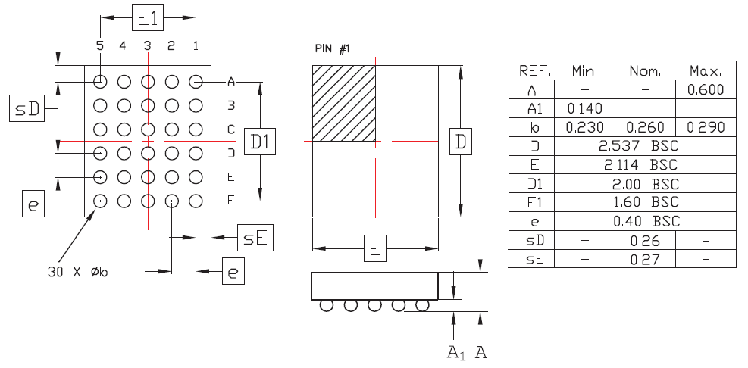

Figure 6. MTX001-30 package

The MTX001-48 is packaged in a 48 pin VFQFN Exposed Pad. Its package dimensions are shown in Figure 7 (in mm).

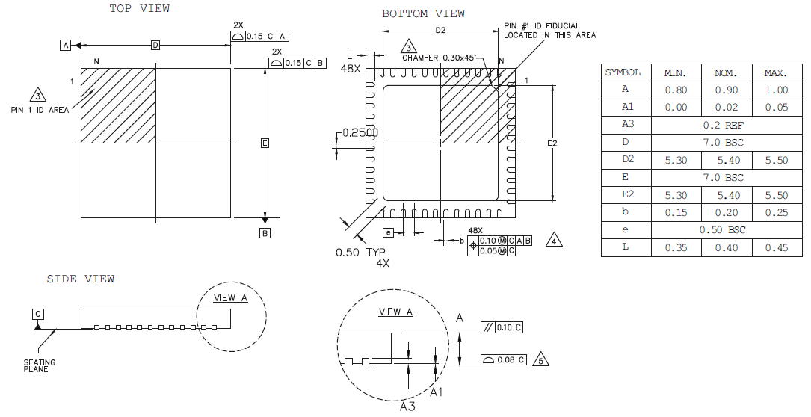

Figure 7. MTX001-48 package

Ordering information

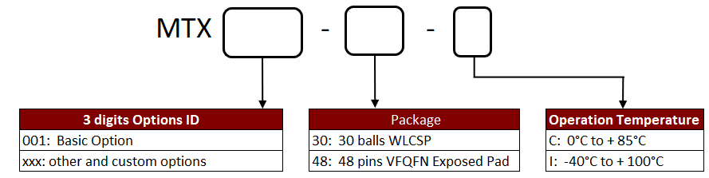

Revision history

Date | Version | Revision
5/14/2019 | 0 | Original revision
02/01/2020 | 1 | Product table added
02/09/2021 | 2 | Timing digarramm updated

Disclaimer

We expressly disclaim any liability arising out of the application or use of the MTX. We reserve the right to make changes, at any time, to the MTX as deemed desirable in the sole discretion of ours. We assume no obligation to correct any errors contained herein or to advise you of any correction if such be made. We will not assume any liability for the accuracy or correctness of any engineering or technical support or assistance provided to you in connection with the MTX.

THE DESIGN IS PROVIDED “AS IS” WITH ALL FAULTS, AND THE ENTIRE RISK AS TO ITS FUNCTION AND IMPLEMENTATION IS WITH YOU. YOU ACKNOWLEDGE AND AGREE THAT YOU HAVE NOT RELIED ON ANY ORAL OR WRITTEN INFORMATION OR
ADVICE, WHETHER GIVEN BY US, OR OUR AGENTS OR EMPLOYEES. WE MAKE NO OTHER WARRANTIES, WHETHER EXPRESS, IMPLIED, OR STATUTORY, REGARDING THE DESIGN, INCLUDING ANY WARRANTIES OF MERCHANTABILITY, FITNESS FOR A PARTICULAR PURPOSE, TITLE, AND NONINFRINGEMENT OF THIRD-PARTY RIGHTS.

The MTX is not designed or intended for use in the development of on-line control equipment in hazardous environments requiring fail-safe controls, such as in the operation of nuclear facilities, aircraft navigation or communications systems, air traffic control, life support, or weapons systems (“High-Risk Applications”). We specifically disclaim any express or implied warranties of fitness for such High-Risk Applications. You represent that use of the MTX in such High-Risk Applications is fully at your risk.

